# Computer Engineering Department

Program: Sem VI

# Course: Cloud Computing Lab(CSL605) PART A

(PART A: TO BE COMPLETED BY STUDENTS)

Experiment No.5

* 1. **Aim:**

# To demonstrate and implement Storage as a service using AWS S3 Service

* 1. **Prerequisite:**

Knowledge of Networking, Distributed Computing and knowledge of Software architectures.

# Objective:

Objectives this experiment is to provide students overview of AWS storages, its Features and Services.

# Outcome: (LO3)

After successful completion of this experiment student will be able to; Implement IAAS deployment model of cloud.

# Theory:

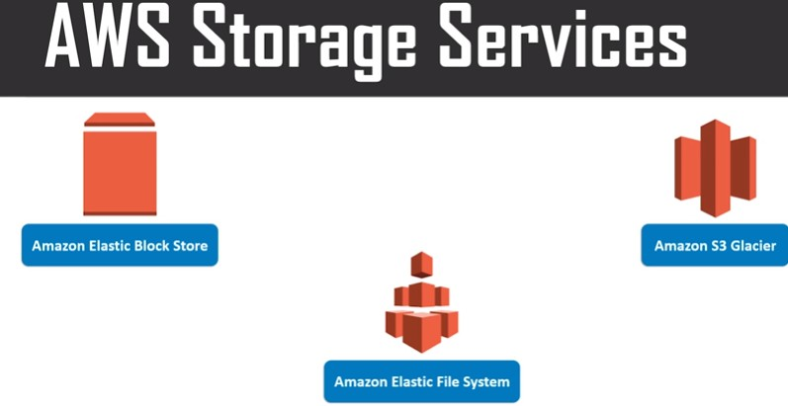

**Amazon Elastic Block storage (EBS)**: Storage in the form of blocks, each of these blocks associated with one particular instance, so when to access this block make sure that you have an instant connected to it and storage is accessed through that instant only.

**Amazon Elastic File System (EFS):** It is shared file system; hence it is not attached to a particular system or operating system.

**Amazon S3 Glacier:** Need to store archive data, certain data that we would not want to retrieve or access on daily basis or frequently, such data you can put on **S3 Glacier**. That is it locks data for certain time during which you cannot access it, once you clear that duration you are free to access that data.

This storage is very cheap as compared to other data storage.

Example: Hospital System (birth certificate data): Birth certificate given by hospital once

baby takes birth, so once you get it you are not requesting it again and again and hospital need to maintain it. That is data which is important but not needed on daily basis.

AWS Storage Gateway: Act as middle ware to move data from one system to another system.

# What is Amazon S3 (Simple Storage Service)

* + 1. Amazon s3 has a simple web service interface that you can use to store and retrieve any amount of data, at anytime from anywhere on the web.
    2. **S3 works on objects and buckets** (Bucket is an container and an object (doc, image, file etc) is an file, which you can stored in container)
    3. Online cloud storage

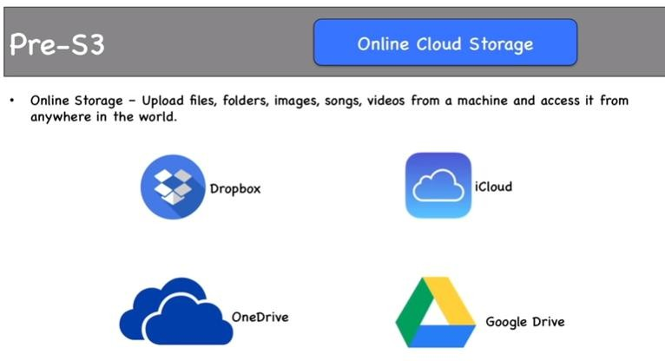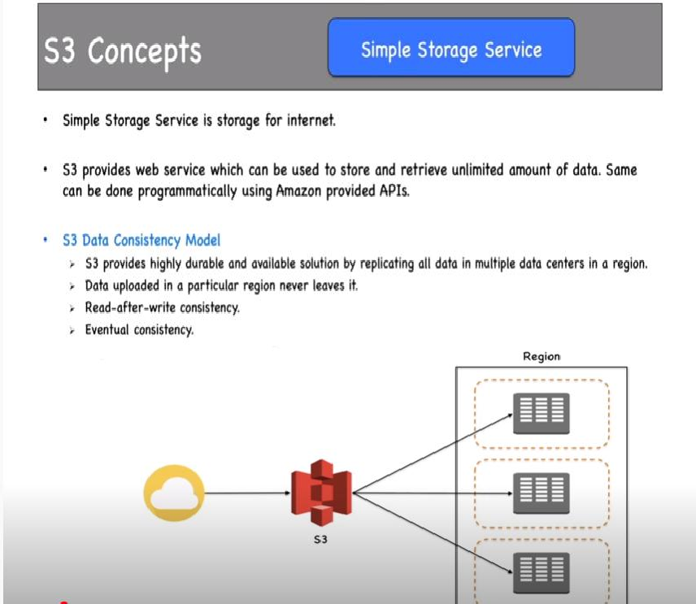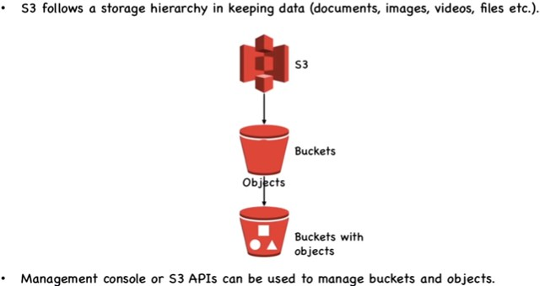

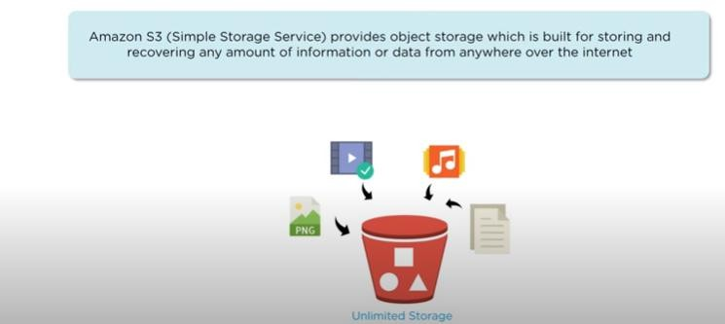

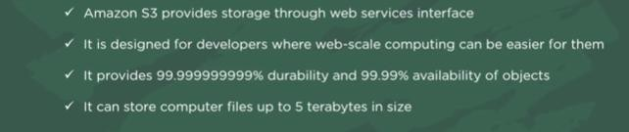

* + 1. 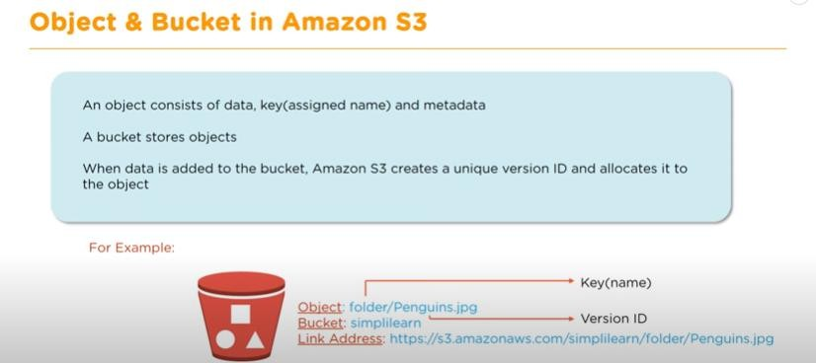

Steps to Implement Storage as a Service using Own Cloud/ AWS, Glaciers

Step-1: click on create bucket

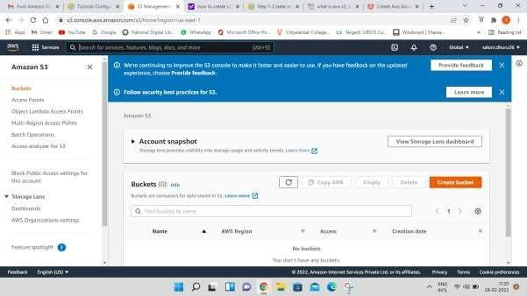

Step-2: Give Bucket name & select region for storage

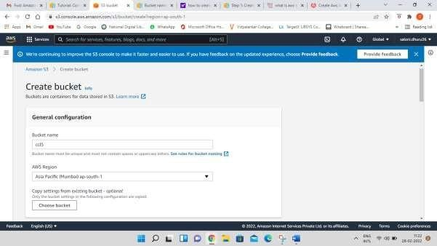

Step-3: Keep object ownership setting as ACLs Disabled as by-default

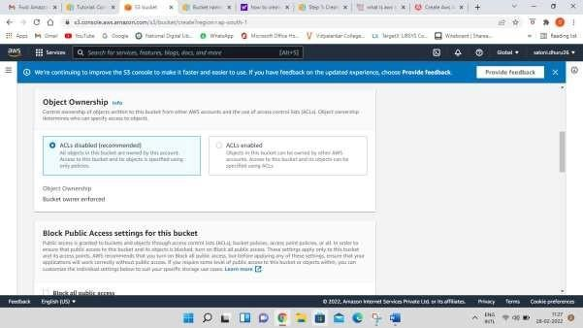

Step-4: Disable block all public access checkbox

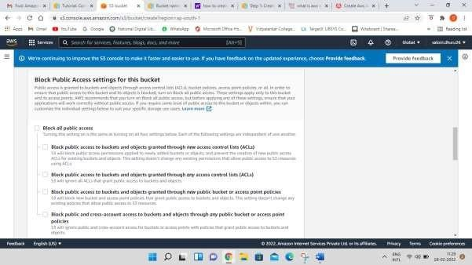

Step-5: Select the checkbox for **Turning off block all public access might result in this bucket and the objects within becoming public**

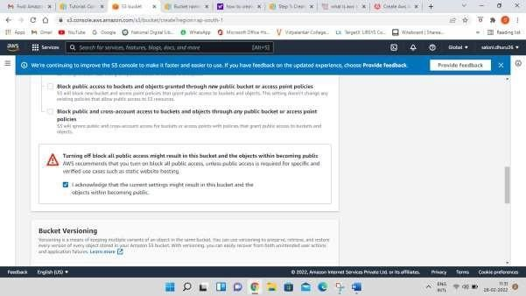

Step-6: Keep bucket versioning as disabled and add tags if required.

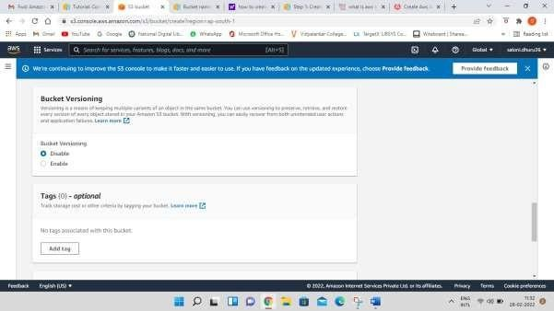

Step-7: Keep default encryption disabled and click on create bucket button

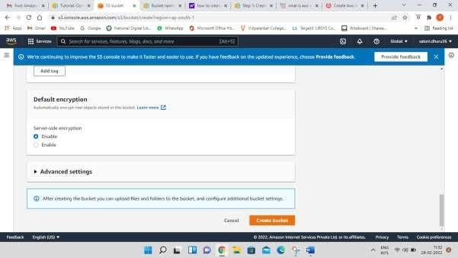

You can now see the successful creation of your bucket

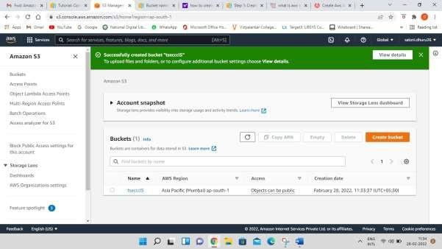

Step-8: now click on the bucket that you have created

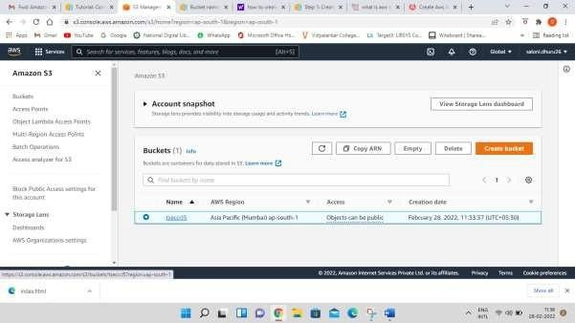

Step-9: You can either create a folder here or upload an existing file in the bucket

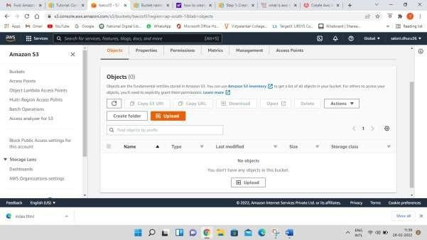

Step-10: now click on upload button and click on add files button browse your local machine and select which file you need to upload on S3 next click on upload button at bottom right end

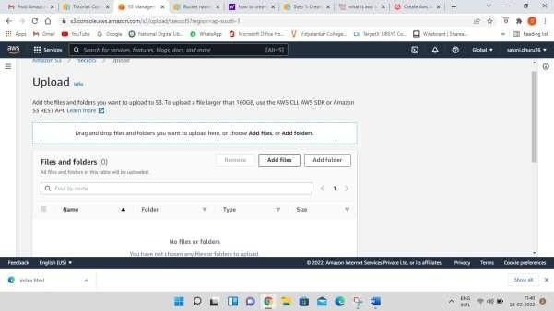

Now you can check the upload status screen

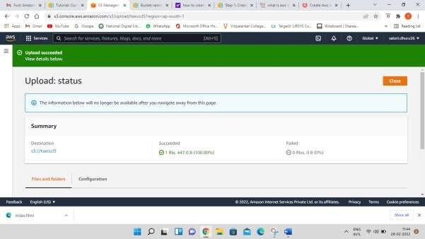

Now click on close button

The screen will appear as below

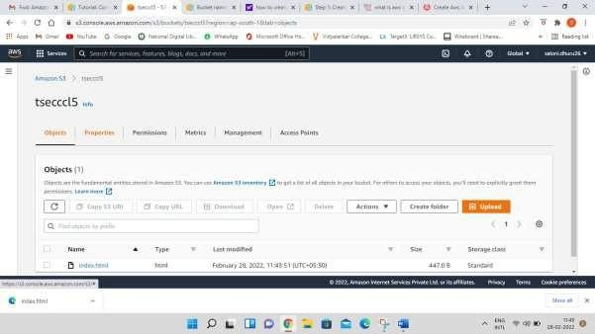

Step-11: Select properties and scroll down to **Static website hosting** option which is disabled now click on Edit option on right side

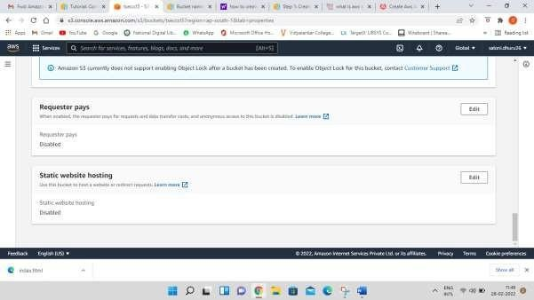

Step-12: Enable the radio button and specify the file name in **Index document** which you have added in S3

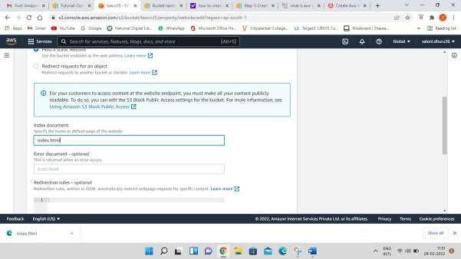

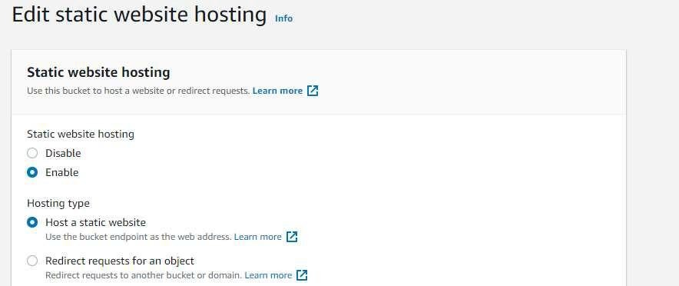

Scroll down and save the changes at bottom right Following screen will appear

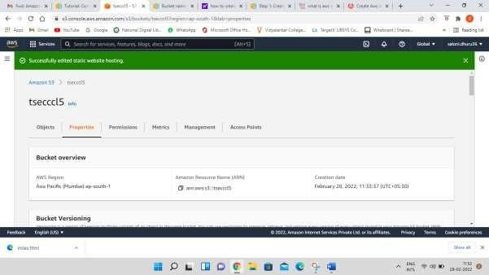

Step-13: Click on Permissions Tab

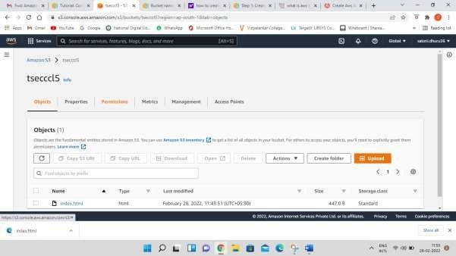

Step-14: In **bucket policy** click on Edit option

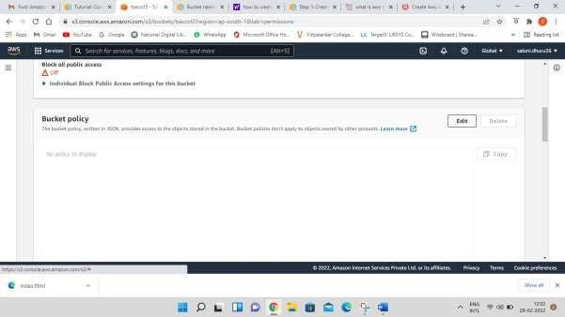

Step 15- after clicking on edit button paste the following code in bucket policy

{

"Version": "2012-10-17",

"Statement": [

{

"Sid": "PublicReadGetObject", "Effect": "Allow",

"Principal": "*", "Action": [

"s3:GetObject"

],

"Resource": [

"arn:aws:s3:::Bucket-Name/*"

]

}

]

}

Note-Make sure that you add your bucket name in the code above Scroll down and click on Save Changes button

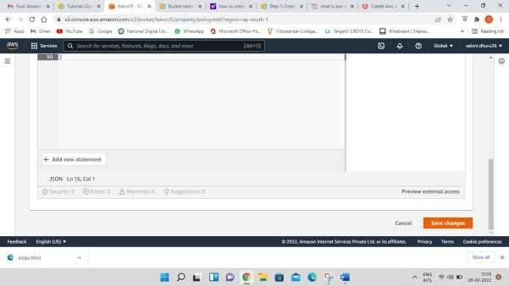

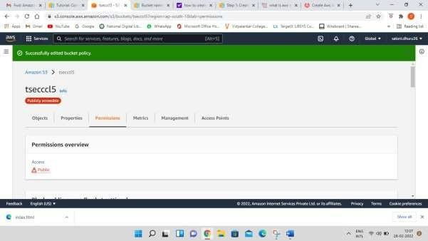

Step-16: open your html file and click on Object URL

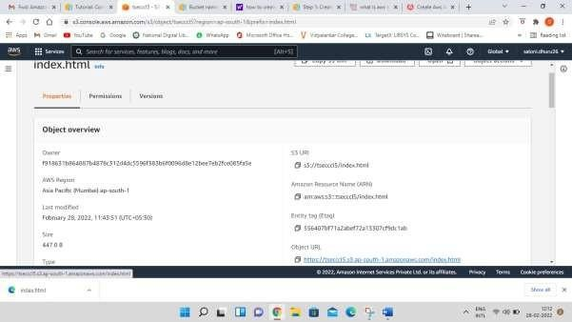

Step-17: Now for delete files click on checkbox of your file and then click on **Delete** Button

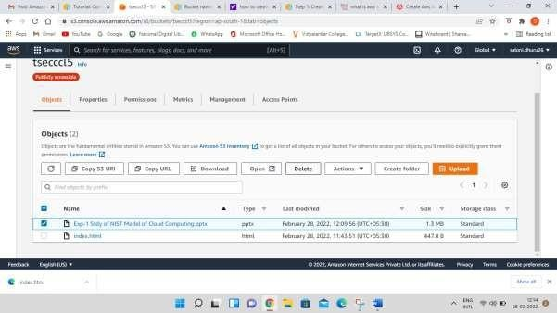

Write permanently delete and click on delete object button

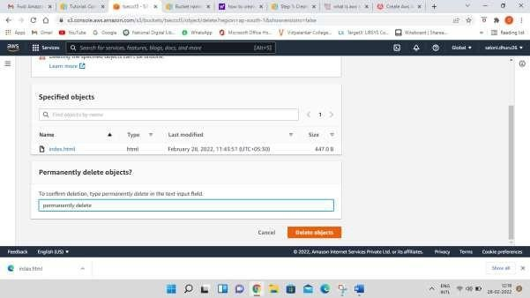

Now click on close button

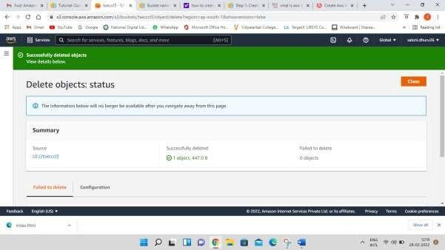

Step-18: now come to Amazon S3 tab and select your bucket and then click on delete button

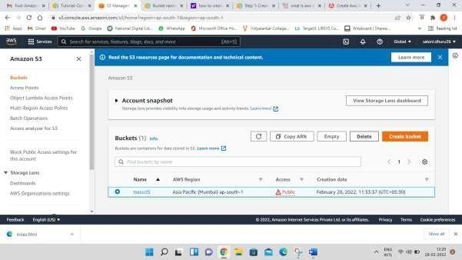

Write down your bucket name in delete bucket tab and click on delete button at bottom right

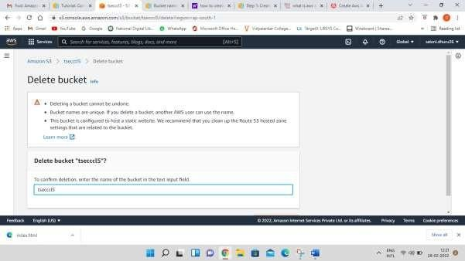

You can see that the bucket is deleted





M

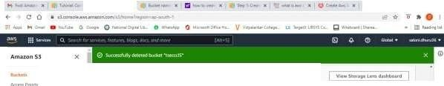

..

" . .._,.

4

*0* X

* Auoutitsnap

"••- -

...........

shot

,_...,..,.,..........- ..-0

f::tj,nl,o-t.c _...,",

"-'t 'W,J>)ll.t((ff:1floillQ

* 0,,.,--

--,_wu

.l.lu,.c,lccts(ot ,..,

@]

..,

•

•

•

l)Oti1W1onk

,.,., ,.._ttn\1 1 ..

"""'" ....



i1P1.CllOV

# PART B

**(PART B: TO BE COMPLETED BY STUDENTS)**

***(Students must submit the soft copy as per following segments within two hours of the practical. The soft copy must be uploaded on the ERP or emailed to the concerned lab in charge faculties at the end of the practical in case the there is no ERP access available)***

|  |  |
| --- | --- |
| Roll No.B30 | Name: Pranjal Bhatt |
| Class :TE COMPS B | Batch :B2 |
| Date of Experiment: | Date of Submission: |
| Grade : |  |

# Question of Curiosity:

***Q.1: Create Bucket using AWS S3 service (Add stepwise screenshots of the same)***

Step-1: click on create bucket

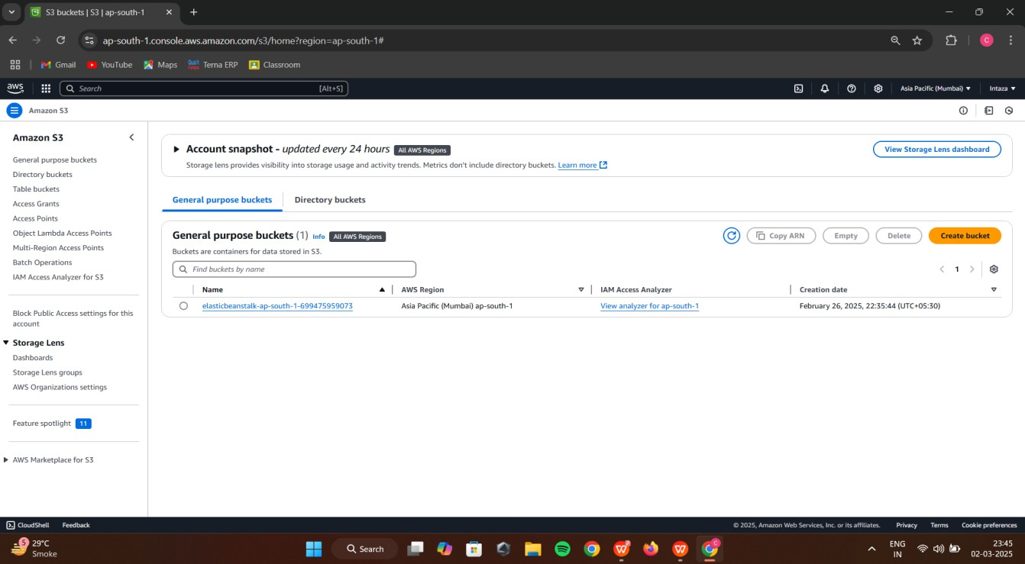

Step-2: Give Bucket name & select region for storage

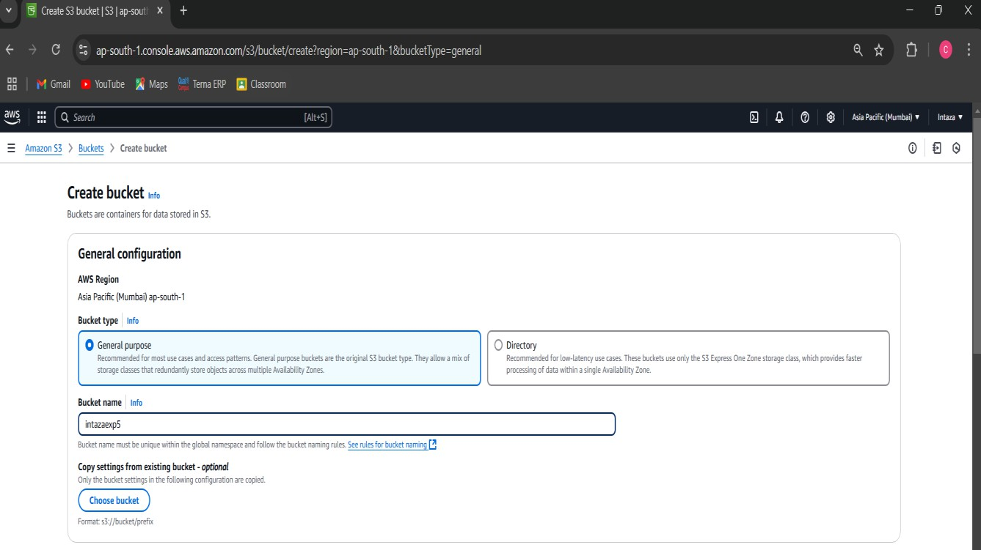

Step-3: Keep object ownership setting as ACLs Disabled as by-default

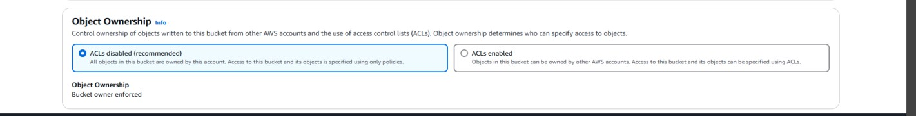

Step-4: Disable block all public access checkbox

Step-5: Select the checkbox for Turning off block all public access might result in this bucket and the objects within becoming public

Step-6: Keep bucket versioning as disabled and add tags if required.

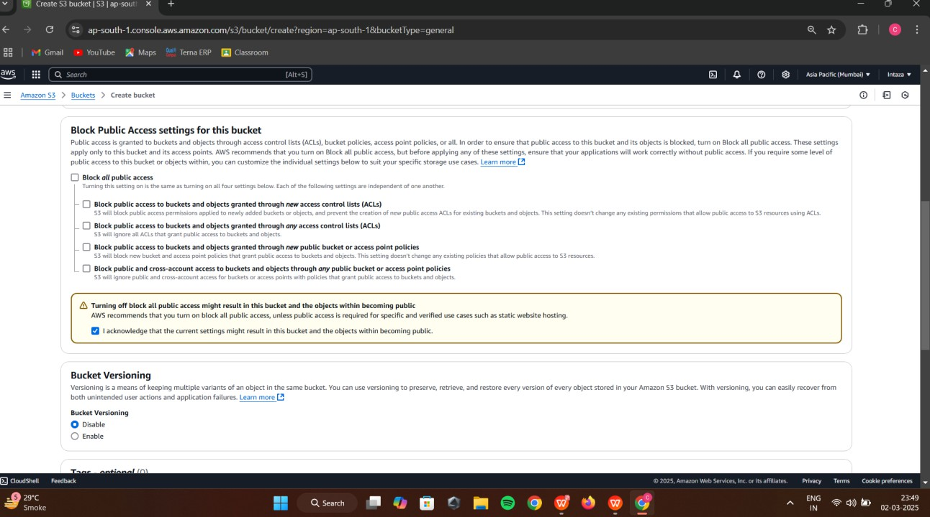

Step-7: Keep default encryption disabled and click on create bucket button

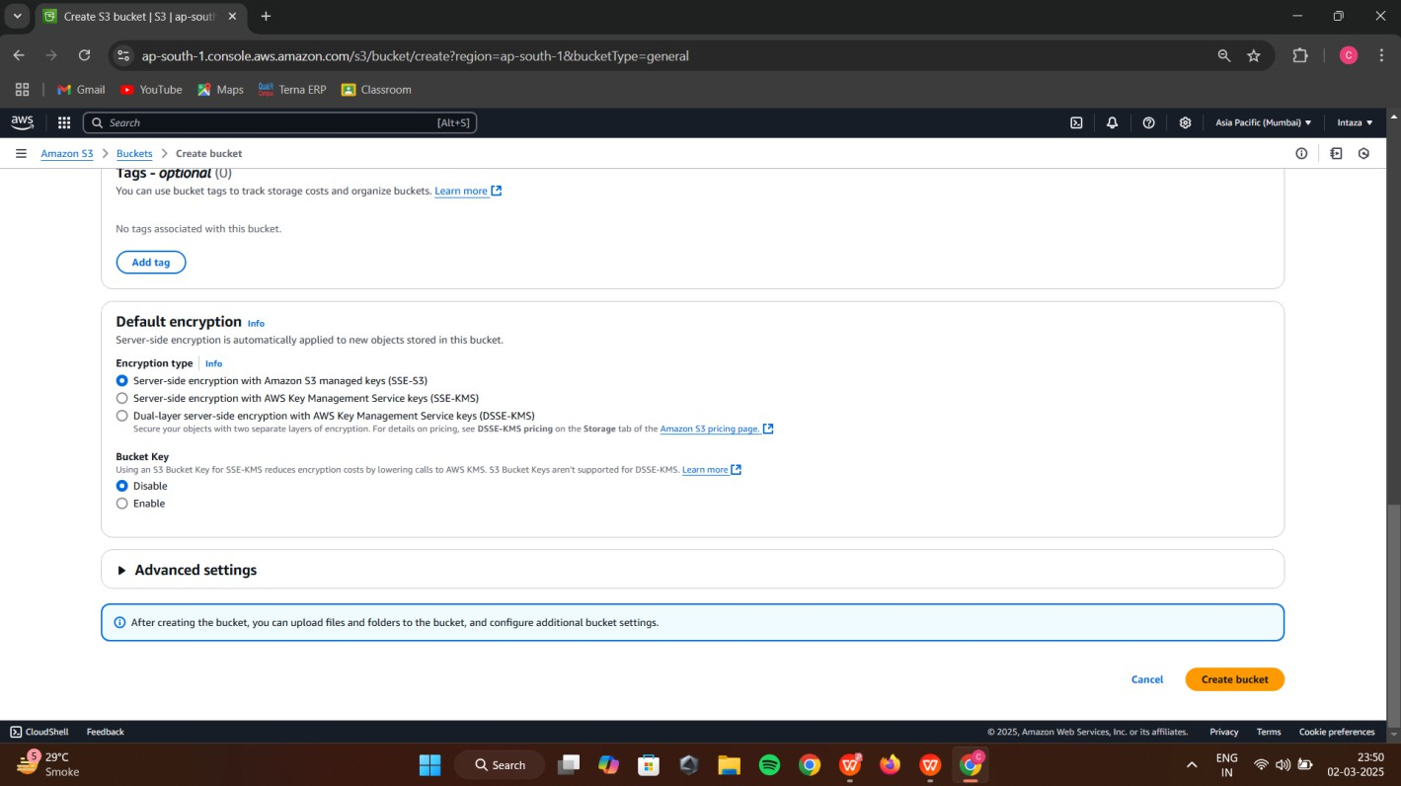

step-8:You can now see the successful creation of your bucket Step-9: now click on the bucket that you have created

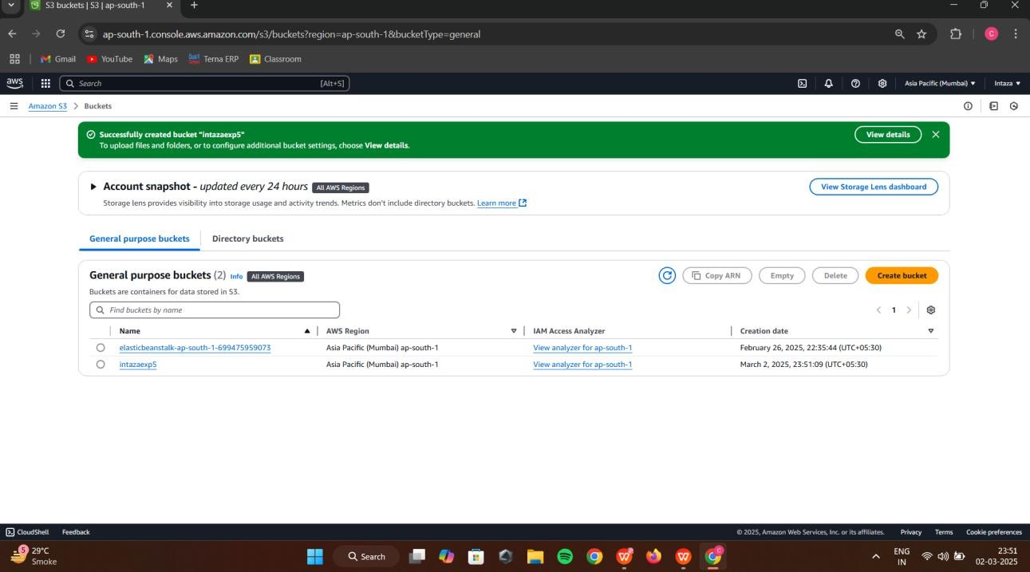

***Q2:* Add Objects to *Bucket created (Add stepwise screenshots of the same)***

Step-10: You can either create a folder here or upload an existing file in the bucket

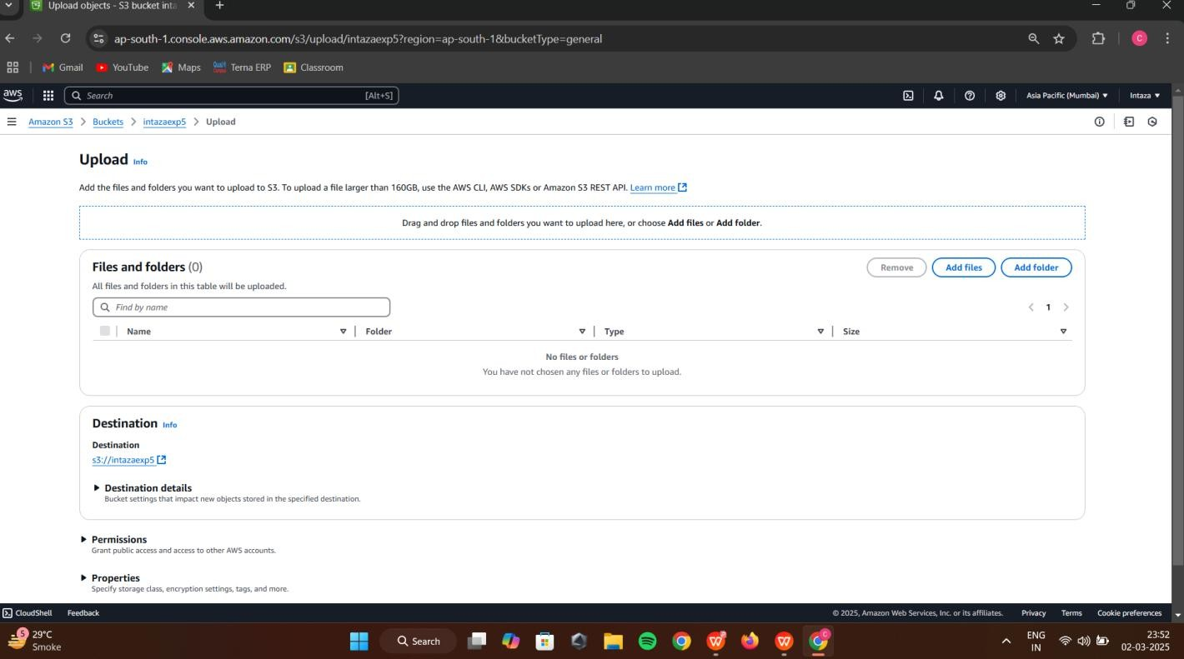

Step-10: now click on upload button and click on add files button browse your local machine and select which file you need to upload on S3 next click on upload button at bottom right end

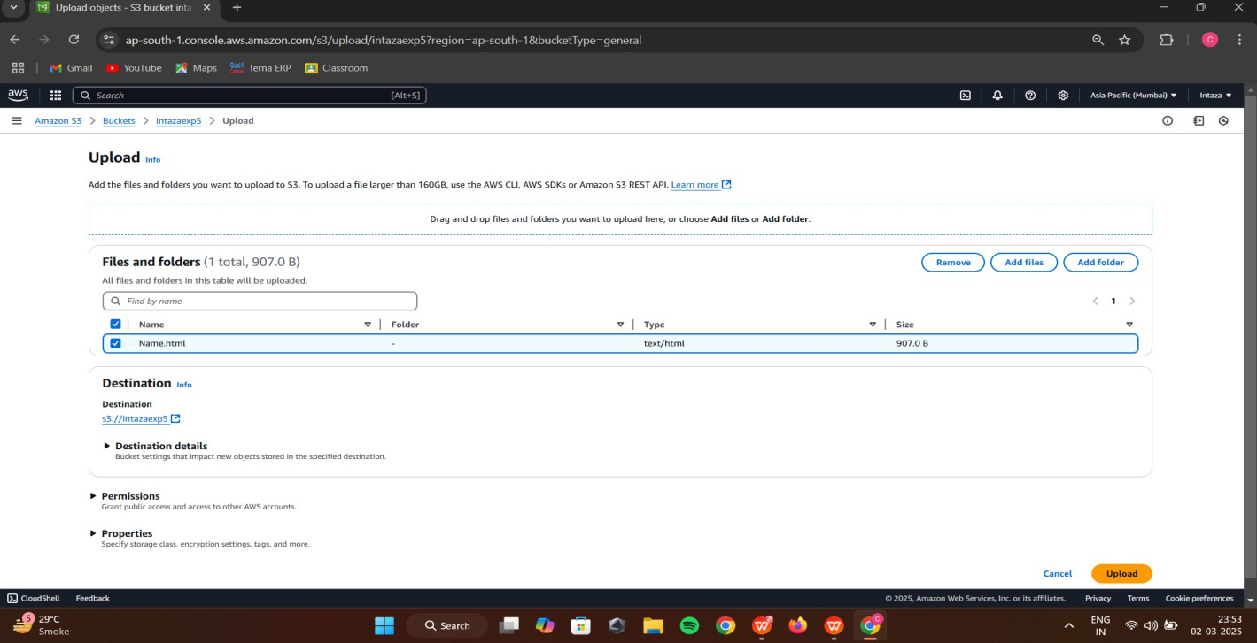

Step-11: Now you can check the upload status screen, Now click on close button.

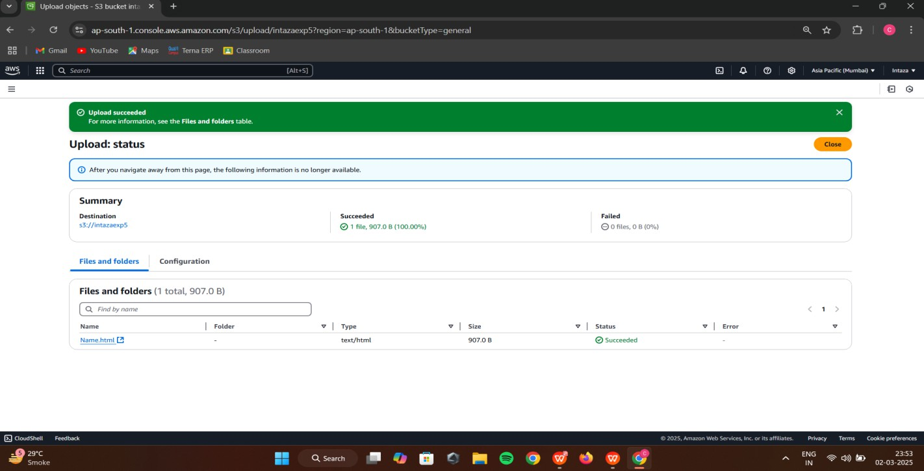

Step-12: Select properties and scroll down to Static website hosting option which is disabled now click on Edit option on right side

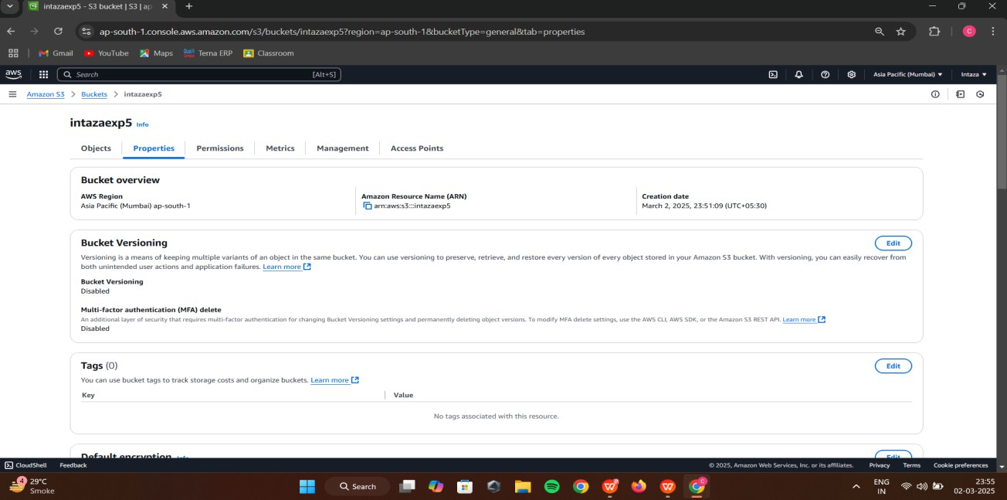

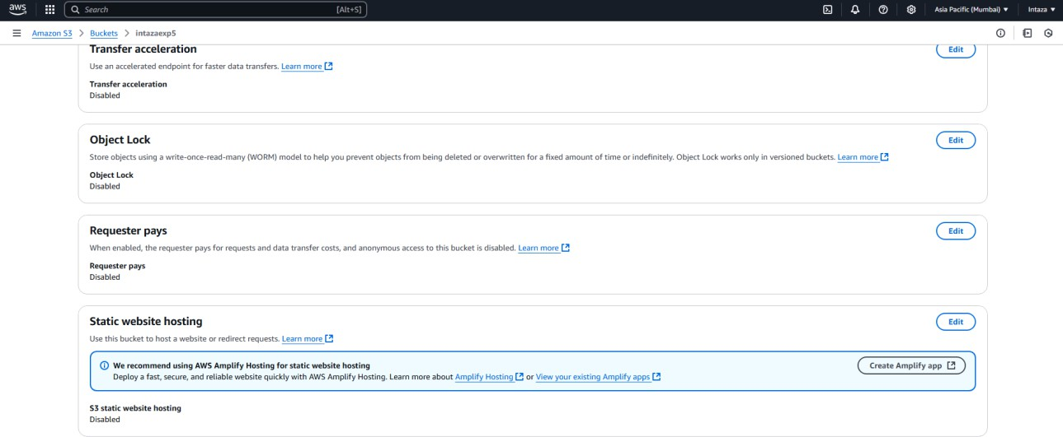

Step-13: Specify the file name in Index document which you have added in S3

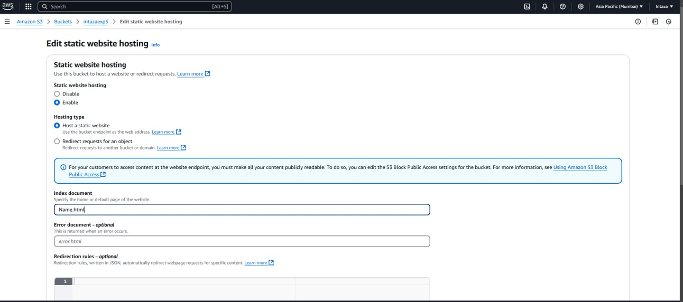

Step-14: Scroll down and save the changes at bottom right, Following screen will appear

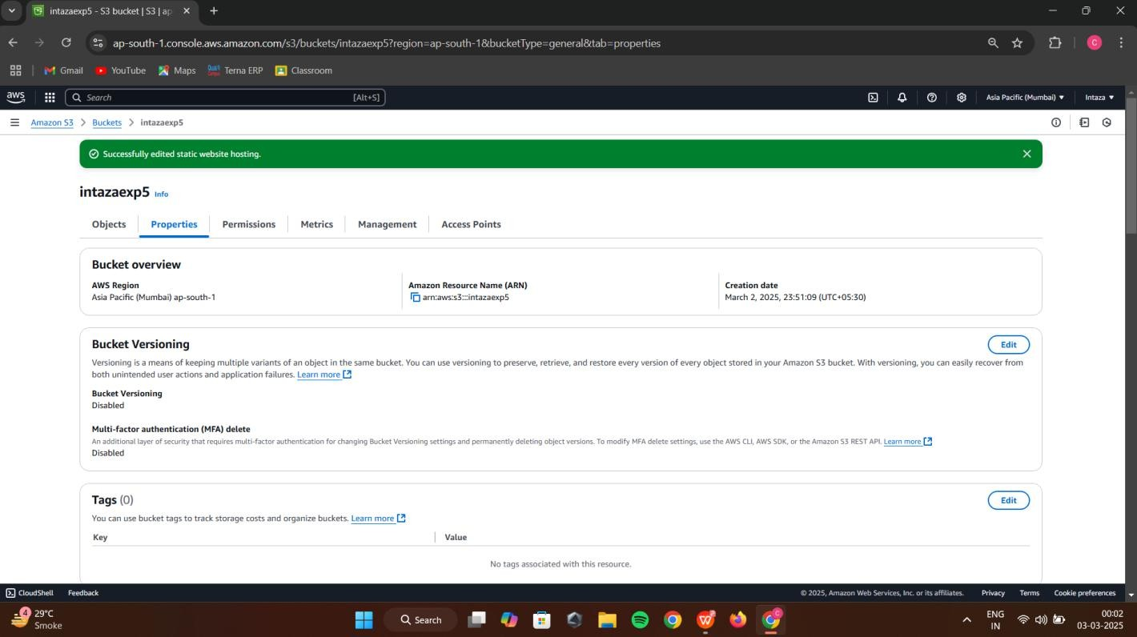

Step-15: Click on Permissions Tab

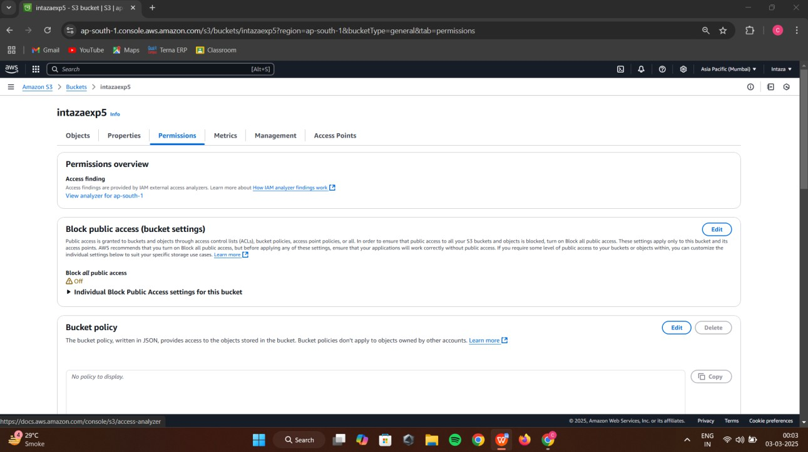

Step-16: In bucket policy click on Edit option

Step 17- after clicking on edit button paste the following code in bucket policy

{

"Version": "2012-10-17",

"Statement": [

{

"Sid": "PublicReadGetObject", "Effect": "Allow",

"Principal": "*", "Action": [

"s3:GetObject"

],

"Resource": [

"arn:aws:s3:::Bucket-Name/*"

]

}

]

}

Note-Make sure that you add your bucket name in the code above

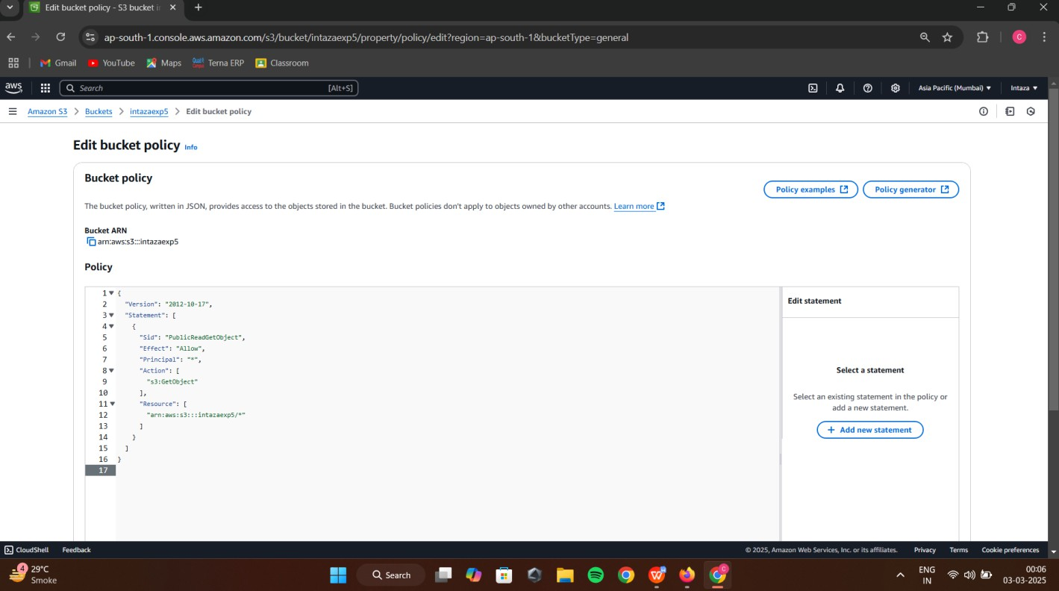

Scroll down and click on Save Changes button

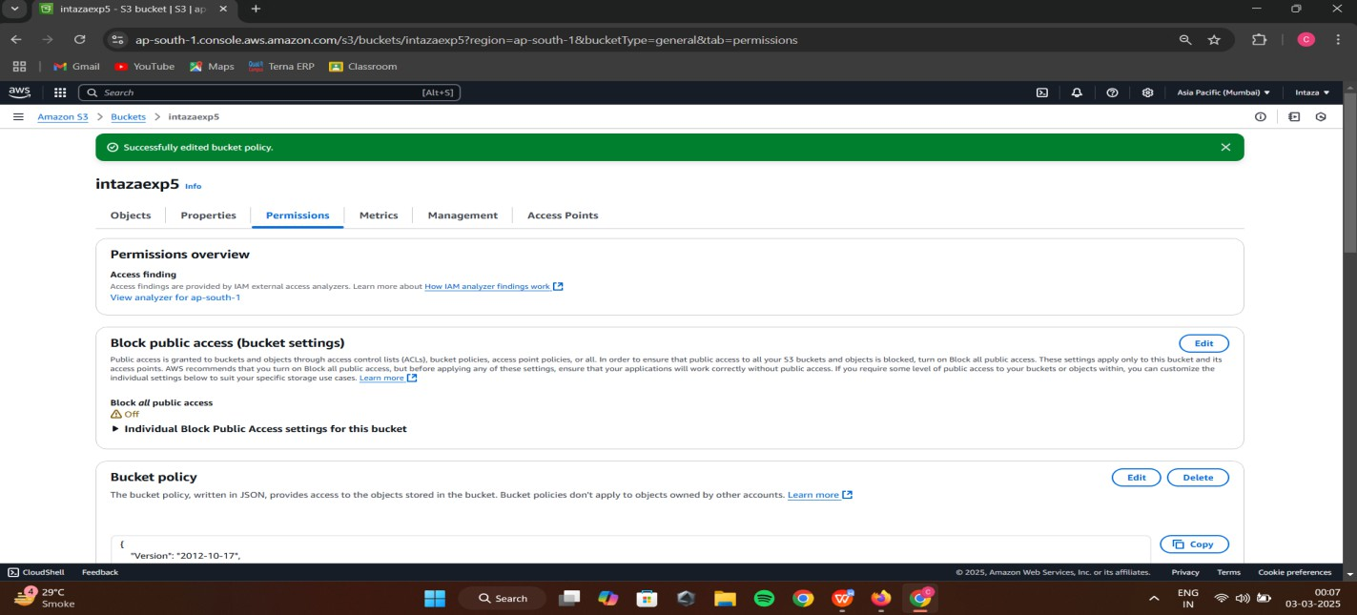

Step-18: open your html file and click on Object URL

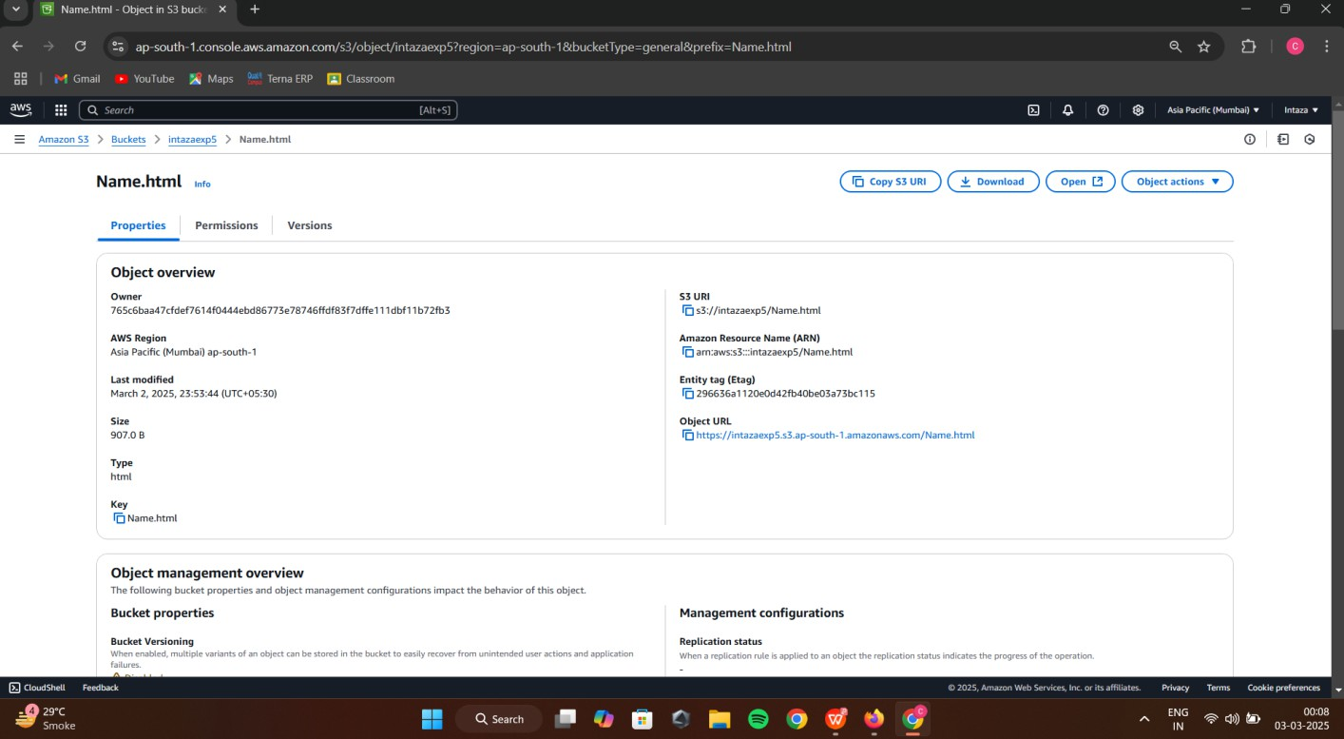

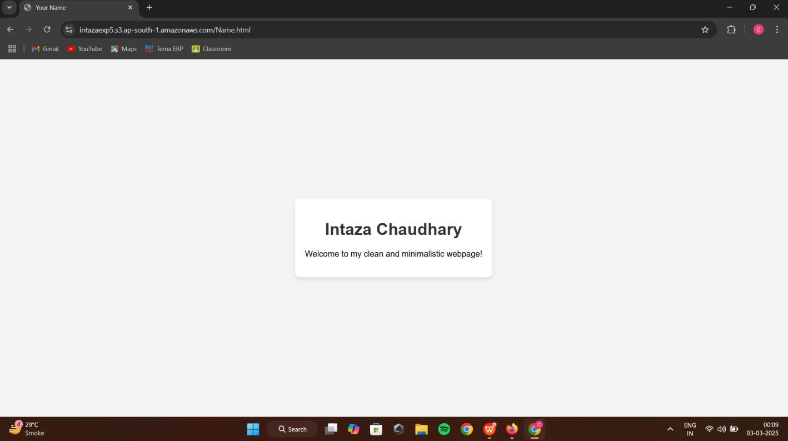

Step-19: Now for delete files click on checkbox of your file and then click on Delete Button,Write permanently delete and click on delete object button

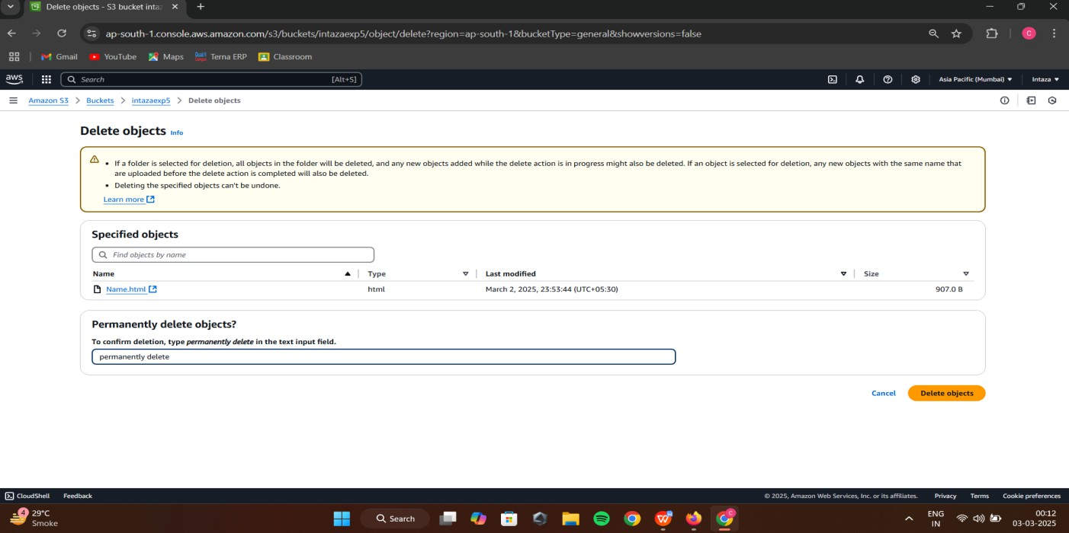

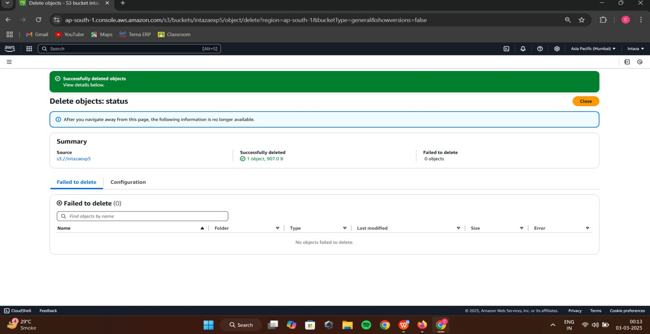

Step-20: now come to Amazon S3 tab and select your bucket and then click on delete button, Write down your bucket name in delete bucket tab and click on delete button at bottom right

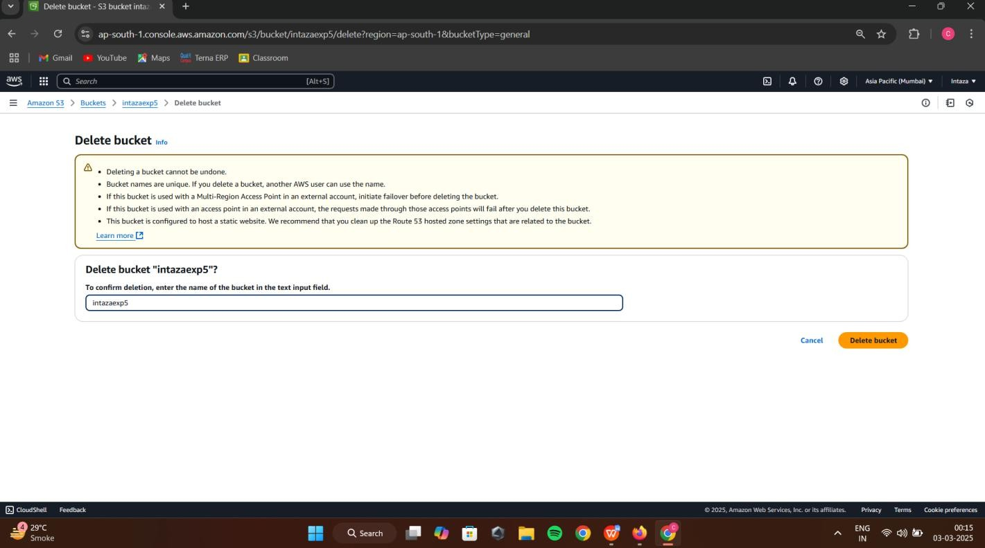

Step-21: You can see that the bucket is deleted

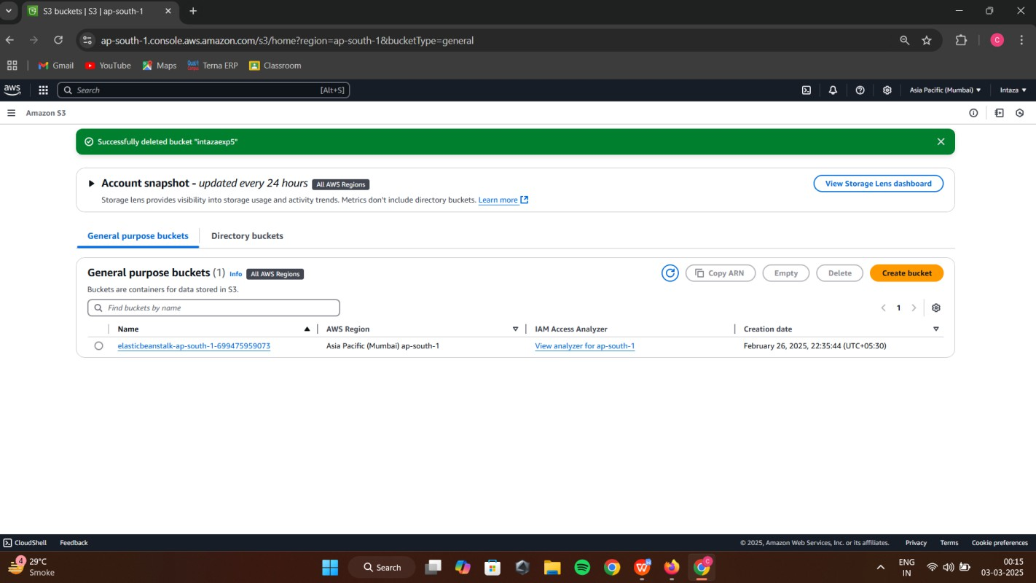

*Q3:* Compare Google drive with AWS S3

|  |  |
| --- | --- |
| **GOOGLE DRIVE** | **AMAZON S3** |
| It is owned by Google LLC. | It is owned by Amazon. |
| It was launched in 2012. | It was launched in 2006. |
| It offers 15 GB free storage space. | It offers 5 GB free storage space. |
| It was developed by Google. | It was developed by Amazon Web Services(AWS). |
| The number of users using Google Drive is more. | The number of users using Amazon S3 isless. |
| It provides full security of data. | It also provides full security of data but comparatively less. |
| It has the maximum storage size of 30 TB. | It has the unlimited maximum storage sizefor paid users. |
| It does not support remote uploading. | Remote uploading is not supported here  also. |
| Maximum file size in Google Drive is 5TB. | Here maximum file size is 5 TB. |
| It supports file versioning. | It also supports file versioning. |

# Conclusion:

In this experiment, we successfully demonstrated the implementation of **Storage as a Service (SaaS)** using **AWS S3**. Through this, students gained practical exposure to various AWS storage solutions, including **Amazon EBS, Amazon EFS, Amazon S3 Glacier, and AWS Storage Gateway**, understanding their use cases and benefits.